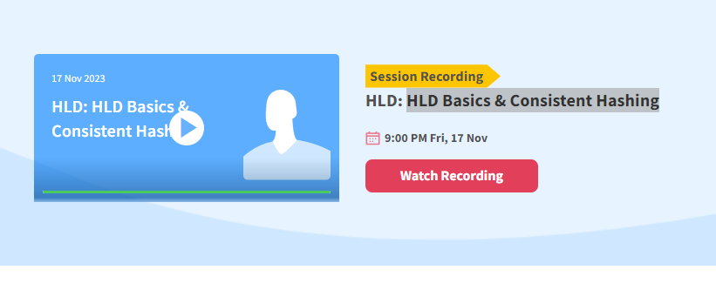

**What is HLD:**

We heard about distributed system and system architecture. All these will be a part of HLD.. if I wanna build facebook, whatsapp clone, twitter clone, Youtube clone etc..

This will be support only few user but a real app supports million users..

To build scalable system is all HLD design about… we know science and arts of writing code in LLD. Here we talk about arch decision we do for a system. How to build a system at scale..

When we see a system like amazon, linkedin, hotstar, here magic happens.. beauty of HLD is done here

In hotstar a million of people can watch a live match can see from any corner of world.. not just the code who does the job done… u have to dive deepr what infra supports, how client laptop connect to internet, reach out to hotstar and hotstar handles 5 cr people. Designing system at scale what HLD does.



People call it system architecture..

People also call it distributed system, in hotstar not a single machine does the job, 100s 1000s of machine together does the job. Computation is happening in distributed manner so callit distributed system.

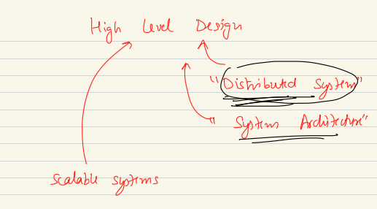

Maintainability of code = LLD.

**Maintaining the machine, how the machine talks to each other, if a computer go down how do you handle, how the machine stays security HLD takes care of it. Though its part of security domain… communication between machine is HLD.**

How HLD is Real life?

**Building a system at scale is HLD.**

**Real life example of Delicious.io.**

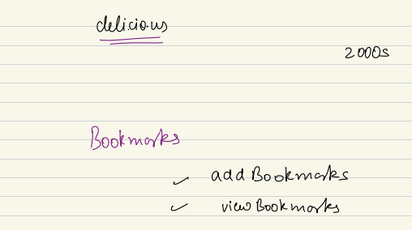

Back in early 2000s internet is new…web browser were dumber, not lot of options. In college library when you open a link, at home you cant open the link. You cant create bookmark. That time web browser didn’t do that. A US student made delicious which allows users to login, bookmark their link. Bookmark manager. Where they can access the bookmark from another computer.. 2 features, add and view…

How would I create a system like this???

From a system perspective.. took a laptop that computer is going to act as server for their website delicious. Server is a computer whose job is to serve the request that come to it.. for that we need to go back to networking class…

If there is a client who want to access delicious and access the server. A client machine will make a request to server machine. To communicate on internet, every communication happen by IP address.. all computer need IP so the request come to that IP. There are 2 type of IP.

No networking class….

Public and private IP.

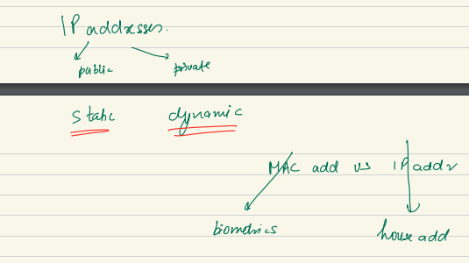

Everyone in world to connect each other through IP address… we can hear tarun as his com has IP and my com has ip through which I am receiving. Where the packets go depends on IP. 2 type of address we hear about… MAC and IP..

Something which can uniquely identify me.. but my address can change.. MAC = address given to my hardware. More like my biometrics. For laptop hardware

IP address: house addresss. I can change the address and start receiving myntra package at new address. When I connect to wifi. I get ip from home wifi, when office network, gets ip from office network..

Internet is network of networks…

Microsoft as a company they can have their oown network. It can be wifi or wer=ired. Channel can be any.. wired and wireless.. 2 machine can talk to each other via network.. when I wanna send message to another I need the IP to another machine..

The network within a org can be called as Intranet. Intraschool and inter school competition.

To talk to other machine within intranet…I don’t need to write exact address unique throughout the world. I can give an internal address. Inside intranet talk to others using internal only address. Or Private IP address… some IP you give to machine inside same network. Ned not to be uniqueue throughout the world.

Inside intranet you can give private IP. That’s enough.

This intranet can also be a part of wider network of multiple internets. mS, google, scler can have own intranet. When I wanna talk to someone else from another intranet then ineed internet. Internet is network or networks..

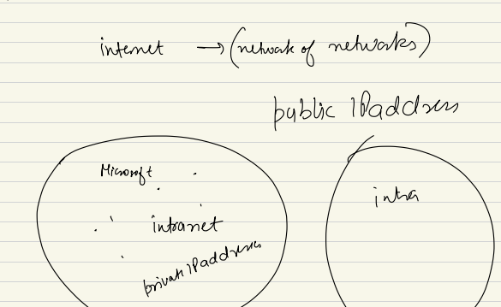

**Static vs Dynamic IP:**

Say I am using airtel or JIO.. when I connect to airtel, I want to access fb, whatsapp to connect to public IP address not limited to my own home ips. Say I have laptop and open Facebook. It has own dataceter. I will type facebook.com on browser and someohow I need to know public ip of facebook so I can reach out to facebook.com. the ip I get usually by DNS… most beautiful HLD concept. I connect to DNS and ask for facebook.com ip. DNS cechks record and give me ip of facebook.com. IP will be public.

Through the phycial tranfer of packets from my machine to FB datacenter I will send a connection request to FB.com and FB will respond to address of my IP. Fb reply to my IP. So for this I will need public IP. So to communicate in internet the client also need Public IP.

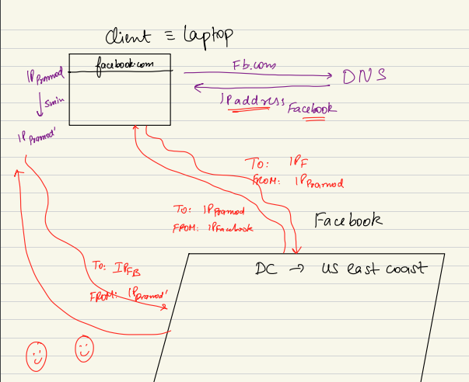

To communicate over internet client-server both need public IP address.

There are billion of devices on internet. Phone, printer, refrizertor, ipad, a lot of ip. Giving a unique/ static public ip address will be huge and waste. Overkill. Not even that, beyond that if I connect to airtel… it has 1000 customer. Say my area has 1000 airtel connections. Airtel will not have 1000 public accessible ip address. Only 100 public ip address . It will use DHCP. Dynamically allocated ip address. So it gives a dynamically changes IP address.

There are 2 kind of machines server and client. Server machine me people will reach out. But client me no one comes to ask for data. 2 kind of system can work with 2 kind of ip address..no internet traffic come suing mac address. No one can send using mac address… cant communicated using MAC. O MAC not need for communication over internet.

Static IP is the IP that should not change. FB.com ka ip should not change. So if peple wanna reach out they can. But on client it will have dynamic ip. If it changes no problem. As when I send requewt to anyone I send a param called FROM. So the response they send to the IP.

If the IP changes after 5 address still everything will work.. as after that I send every request with from and to.. so fb knows where I need to send the response.. this transition can result in some packet gets lost at the time ip gets changed… that’s fine I can retry..

Static: don’t change, remains same. For server we need static IP address…

Client = dynamic, we can still work.. usually just send request. As its cheaper…. As a airtel customer I pay 700 rupee/ month.. we send request with afrom parameter so server can reply to the from address. If a package gets lost I can send a new request to server…

**why static is so costly?**

Scaler.com: server. People connect. It’s a static ip. They pay in lakhs/month. Need a lease line. Ip is specific to me..

Gateway, proxy, reverse proxy..

Delicious: a site service is bookingmarking service. Wrote code to handle bookmark. It needs public static lease line. But static public ip. Connect laptop to this static public ip.

Then do DNS registration. To call someone I need to get the number as I create contact on phone. Just dial used to have number. As human we remember name but not number. Ip address are number. Ipv4 = 32 bit. V6 = 128 bit.

A common registery which keeps registration of everyone’s IP. Its DNS. Some type of key-value pair.. Mapping of domain vs IP address.. dns = domain name server…

So delicious goes to DNS and register the Static IP. Add regstertatioon in DNS records.

If a client in india it will type delicious name and get ip of delicious.. send a connection request. Establish. Send request. Delicious will response to client.

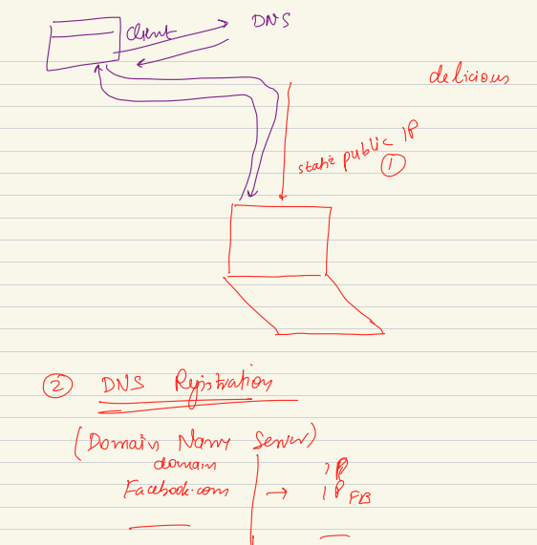

User enters the domain name. but communication happen on IP. Converts domain to ip.. and server send response to client IP>

***Dig deeper:***

DNS = domain name system is nothing but a hashmap. Key-value. From system design perspectice most scalable and interesting system. In relaierty it’s a giant. Sys arch giant. A lot of concept we ened to know to understand DNS.

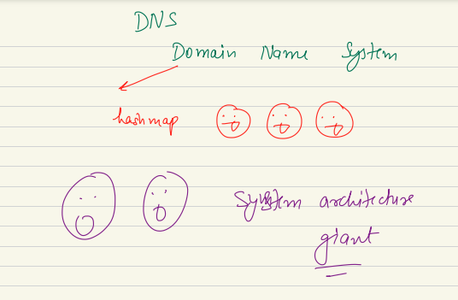

Fb is in US. The people/ client who use FB from all across the world. Everyone remember fb.com domain name but not the IP address. First step is DNS registration. DNS need own server so people can reach out to DNS. If DNS has a server in Europe, client first need to reach out to DNS first. But how? To find specs I need my specs first problem. Where will I go and find DNS.

When I connect to internet, the ISP as a part of network configuration I get DNS configuration. If there is 1 DNS server. All people gets DNS fetch and we go for every website in the world. Not only FB. So the DNS system is a Giant. Not just a small Hashmap. It needs to handle request at internet scale. Internet scale >>> fb scale.

If the DNS is at Europe and all over world ka peope they need to connect to DNS get mapping and then connect to FB.com.

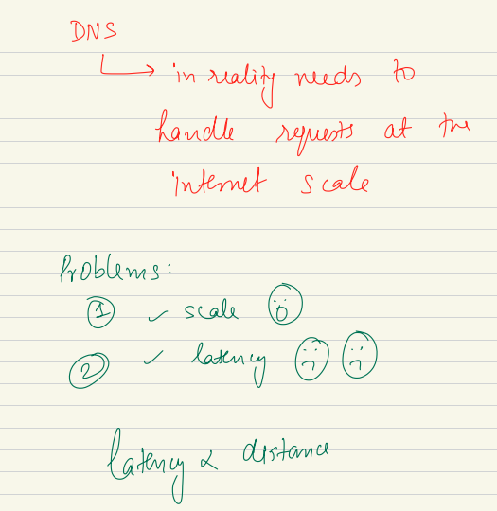

Scale = amount of traffic will come

Latency problem: even I connect to wifi. If I try to connect to FB, package will flow by wifi—router—bigger router—cable bottom of sea floor. Packet will physically transfer through the world to fb.

Wifi signal to connect t o router.. then optical fiber cable at bottom of sea to physical transfer of packets.

Its not magic. Not just coding. The packets will have to travel across ocean and reach of facebook. Optical fiber me speed of light. Latency = time need to response back. So latency will propotional to distance.

Latency is depend on distance. So we need CDN, Caching.

So many people connect to DNS and overburden. Also long distance to DNS resolution. Spend lot of time. If DNS resolution takes time not good.

In reality it happens instantaneously.

DNS – using IP of DNS I connect.

**How solution looks like:**

DSN has 2 problem, scale and latency..

Lets lok at sneak peek at solution today:

DNS is most interesting distributed system. It solves the problem by leveraging the idea of distributed system. I will have not one but hirercy of DNS server. At top level I will have TLD (top level Domain). For each TLD domain .com, .us, .edu, .org. for each of these TLD DNS has diff TLD servers. Inside these server I will have diff child level servers.. child server, which will have diff domain inside them. Diff DNS zones..

DNS structure like a tree.. some root and then for every TLD there will be 2nd level server, and then 3rd level. 2bd, 3rd server will be spread across globe. DNS resolution will be like recursive resolution. Its not single DNS server. A hierarchy of machines spread across globe together acts as DNS. It’s a distributed system. All domain are not in single DNS server.. DNS is multiple machine as distributed system together acting as DNS.

For every resolution you don’t need to go to ultimate authorities server to get your answer. DNS use Caching heavily.

2 concept used here: distributed system/ sharded data. And Caching.

What is caching: I go to google.com many time in a day. Everytime I go I don’t bother DNS root server for the IP for DNS. Static. So they are static not expected to change. Rather than going to source I can copy and stoire nearby. This idea of creating a copy is called caching. For DNS browser keeps the cache. Browser itself is the cache. Also my OS itself is a cache. If I now use EDGE browser, my OS canmaintaina cache.

Browser maintains Cache. OS maintains Cache.

Also Router maintains cache. If I use new devise, I can use router cache.

Neighborhood DNS server keeps cache. All popular domains it caches.. the Neighbourhood DNS. But it might not have a zimbaboew website in cache as its not common here.

Every level such as OS can store 100 sites, most frequently used.. or the NC can save 1000 common sites. Majority of DNS request will be resolved either inside home or NC. So I don’t have to go and travel DNS root to get values. Latency will be lot lower.. I don’t need to go to the root itself.

Distributes system : not a single machine, multiple machines.

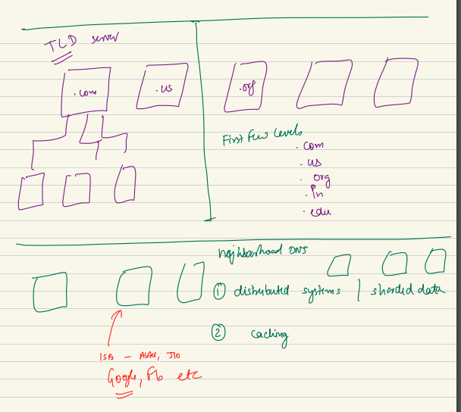

Delicious: the college wanted to host site delicious. He wants to run site in computer. Bought a public static IP address. Also bought a DOMAIN name.

Godaddy is a aggregator sales DOMAIN.. directI.

These domains add all top level DNS resolution is owned by non-govt org called ICANN. They sale the domain.

Go Daddy is agent, they buy from ICANN and sells to us. ICANN uses these money to maintain the DNS resolution.. to level… GoDaddy buy fromICANN and sale to end user.. so delicious buy the domain name.. we do DNS mapping for the Domain name I bought and the IP I have..

**Who pays money to Maintain the neighbor DNS:**

2 kind of entity the ISP such as airtel, JIO they spend money to maintain neighbor DNS.. why they do this? Not charity. They do that as its their interest to give us good/fast internet to their user. If I want end user to access internet quickly, user need to access DNS quickly as well. Is DNS resolution is taking time even internet is fast end user will be unhappy.

So its logical for them to do for their customer.

Also Google, facebook maintain DNS. Google operate in internet scale. If more people can access google faster, they make more money. So DNS eco system is good. So they buy and maintain neighbor DNS.

**DSN is security variability**: DNS spoofing. if my network is configured to JIO neighborhood DNS I can change and make it to google DNS. If I connect to wrong DNS everything can go wrong for me..

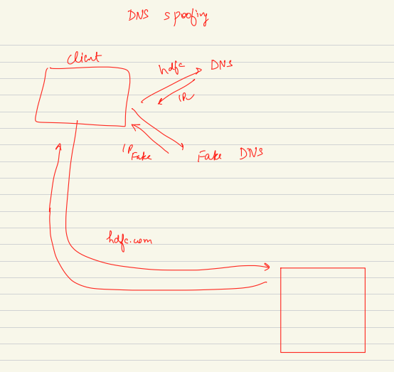

**DNS SPOOFING:** if I change my DNS. Rather than connect to correct DNS if my client starts to connect FAKE DNS. And I try to connect of HDFC.com I go to DNS and get IP of HDFC.com. when someone connect to fake DNS and ask for ip. The Fake DNS can give fake ip and I get connect to a fake server who send a HTML, CSS page who looks like correct HDFC and ultimately, I send my data to a fake site. So security vulnerability.

Never use public wifi to connect to bank sites ETC.

Delicious: bought public static ip.. users are clients and start connect to Laptop… this site became so popular and speared like wild fire.. when it launches got immediate popular. Once its popular and many people started using t became problem in HLD perspective as a single laptop cant handle so many request at same time.. a lot of bottleneck arise.

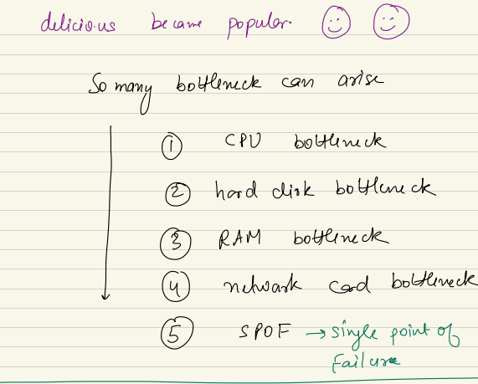

CPU might become bottleneck as laptop that time might be a quad core or duel core prcessor. Cant handle these many req.

Hard Disk might become a bottleneck: we store many bookmark and run out of space.

RAM: main memory can become a possible bottleneck.

Network card: every device we connect to network / internet has a NIC(network interface card) this card Is the card connect to internet and send receive packets, if my internet is good but NIC cant handle high bandwidth, it becomes bottleneck.

Also we have a SPOF (single point of failure): if laptop restarts all user will be disconnected. Bookmark will be stored in hard drive, wont lost.

This problem happens when my system starts to scale. We face a lot of challenge when system scales.

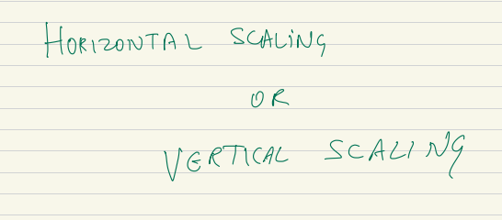

When we have scaling challenge, we can handle via any of 2 ways… Horizontal or vertical scale.

Vertical scaling: whenever you hit the bottle neck of scale you throw the machine away and buy a better machine with better RAM, HDD, NIC. Replace with a fancier machine. Machin = server= Node same thing here.

So one way is to buy a fancier, bulkier, beefier machine. Means Vertical Scaling. Like a normal laptop to a Gaming Laptop. This can handle scaling challenge for me.

Horizontal Scaling: it means , if I have one machine, when can’t handle lot of request.. lets buy lot more cheaper commodity hardware. Add more small or cheap machine in the cluster. Rather than buying fancier machine lets do horizontal scaling. throw small/ cheap machine to the cluster. Uses the idea of Distributed system work together in distributed fashion. They together can do the job for me. Uses idea of distributed computing. Not just a single machine work for me.. Bunch of machine together in distributed fashion doing the job for me.

Both approach has own adv and disadv..

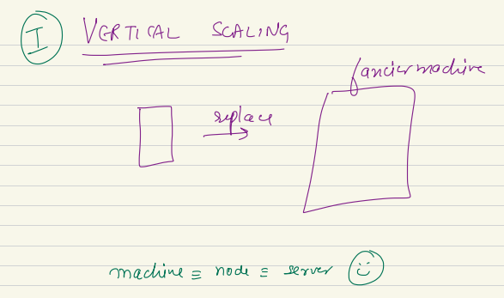

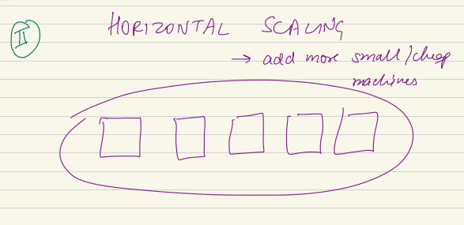

The Reality is *there is no free lunch in world.* In system design is a BED of choices/ tradeoffs. Here we have so many options, every option has own pro and own cons. Among 2 option, Whichever you select will have own trade off. Not a perfect solution. Depend on problem you have you select one solution. You trade good and badness and depending on your problem you pick. Live with some upside and get some downside. No perfect solution. Depending on problem you have, you will pick the right one.

In future will have more and more trade offs.

Any option has own goodness and badness, you have to pick one and live with some downside.

QnA:

***If my IP changes in between a request. How FB knows my server got changed, how FB will reply back to my new changed IP?***

Reply gets lost. So you actually redo the steps so that you get at 2nd iteration. Our request and response can get lost. A concept IDEM potency is used here..

In the client server model: server never initiate the conversaion, or message. Client-server doesn’t support initiate a message from server end.

HTTP long polling, websocket they use here. Will come later.

FB never keeps client IP. Never initiate a conversation on its own.

***Intranet and internet diff…*** for system when we communicate within intranet. Public: addressable in wider internet. When I need communication in larger internet we need public. In same org, 2 location, 2 office. They connect in same Intranet. But outside of intranet you need public ip.

* Facebook.in and facebook.com: take to same resource, same page… but 2 diff domains.

Why google, Airtel will have DNS: so their user can access internet quickly. They will be happy users. Airtel invest in neighbour DNS to get quicker DNS.

FB and Google do that as the money take makes directly related to more people access fast internet. So if company work at planet scale will invest in DNS.

* Load will be distributed across multiple machines.
* We have a req to scale service written in Node js. ??? will look later. Write and read scaling.. we can write a wrapper to shard mysql and use CH to use sharding is some machine. Also introduce batching as well.
* Does CPU processing depend on read or write intensive? CPU will process every operation I do.
* Client initiate a communication, server reply to client IP.
* What is diff mac vs IP? MAC is physical address, IP is networking address. MAC is like biological. For communication IP will be address
* VPN is not synonym of internet. VPN is a way to be a part of intranet, even I am away from the intranet. It’s a strategy uses tunneling to behave a part of intranet.

Read OSI model to understand MAC.

***Components of DOMAN Name:***

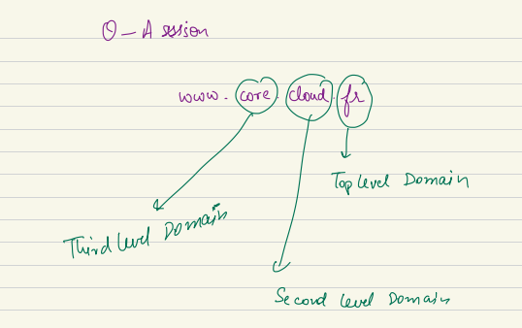

[www.core.cloud.fr](http://www.core.cloud.fr) – this is top level (fr)

cloud – second level domain.

Core – 3rd level of domain.

Some has 2 some has 4 level of domain..

When you by a domain name, you just buy. Then you buy the static ip and bind them..

No of entry, every cache has some limit. Uses most recently used, least recently used when you reach limit it deletes some.

Question: deliciuous is hosted in single laptop. When we say my cpu is 2.6 GHz. Its the clock speed. Unit of frequency. Clock speed. How many unit operations CPU can run in a second.

High clock means you can do many operation. Operation: add, fetch, read, write.. go to disk.. read, value bought to main memory and spend some cycle to read from main memory (RAM). Its CPU and disk operation. Combo of both. HDD—Ram—CPU.

DNS – is a distributed system, horizontally scaled connected with a load balancer. When DNS is configured in ISP level if I use my internet connected. I go to neighborhood DNS, if its there it gives me IP if not it takes to top level domain to resolve it. Sequence of step to get it from ultimate source. What I search also help my neighbor.

chatGpt: first few people spend some time to get it from main DNS, once got popular new people got the mapping quickly..

Bottlenecks:

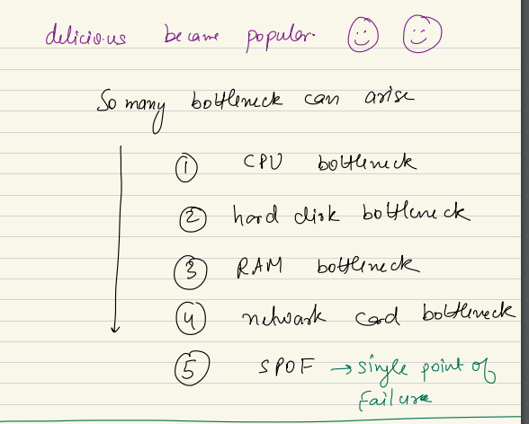

Need of distributed system will come later.

Cats request can be solved by any cast IP.

We connect to anycast network. That machine acts as cache. If I have that there or not I go to TLD..

When we spin up a VM: is it static ip? Yes. that’s a static IP but not a lease line for me. Tahts Lease ip amazon bought, amazon renting to me.

If I want to build my own system, static ip I own. Owner of lease line. More than EC2 instance.

If u learn HLD, you will do great in own job. Learn more and be a better engineer and complete engg. For less exp they have project round or managerial round. In those round if I have goo understanding. I can easily qualify. There I can show I am full fledge engineer. For senior engg this is even more important.

How laptop find DNS with no cache: DNS is configured at network configuration. When I connect to a network, There I get DNS address. When I join I get the config. One of the config is DNS.

The knowledge which is given here by instructors is something which is gained through years of experience which is given to us in easy format in 2 months. you will need it in future so irrespective of your experience go through HLD classes.